**TRAFFIC VIOLATION DETECTION SYSTEM**

**NANDHAGOPAL B¹, Dept of IT KALIDASS S²,Dept of IT**

***VELAMMAL COLLEGE OF ENGINEERING AND TECHNOLOGY VELAMMAL COLLEGE OF ENGINEERING AND TECHNOLOGY***

***nandhu16092020@gmail.com kalidasssivaji18@gmail.com***

**DR.P.UMA MAHESHWARI,**

***ASSISTANT PROFESSOR,DEPT OF IT,***

***VELAMMAL COLLEGE OF ENGINNERING AND TECHNOLOGY***

* **ABSTRACT**

Traffic infractions may result from an increase in the number of vehicles in metropolitan areas. These infractions include reckless driving, exceeding the speed limit, signal jumping, hit-and-run, riding without a helmet, using a phone while driving, parking in the wrong spot, and going in the wrong direction. Tracking these behaviours becomes more difficult and time-consuming. Due to the severe property damage and subsequent accidents, people's lives are put in danger. Automatic traffic violation detection systems can be installed in high-traffic areas of metropolitan cities to prevent such unimaginable effects and to offer appropriate solutions for traffic violations. For which the system constantly enforces appropriate traffic laws and detains those who disobey them. The proposed system includes a traffic infraction monitoring system, CCTV cameras, and an alert messaging systemTo monitor number plates and vehicle speed, CCTV cameras include automatic number plate recognition cameras, speed cameras and red light cameras. The system comes with a user-friendly graphical interface to make it easy for the user to run the system, monitor traffic, and take enforcement action against traffic rule infractions.

* **INTRODUCTION:**

It is obvious that it is getting harder to keep an eye on everyone in these circumstances due to the number of traffic that is increasing, and it is also getting harder to keep the traffic under control because it requires more manpower. Additionally, this issue may result in traffic violations, accidents, and other hazardous situations. As a result, this research work suggests an automated system for keeping these infractions under control by creating a system with the aid of computer vision that detects infractions caused by vehicles and identifies the registration number of violated vehicles in order to send a warning to the host. Computer vision, in general, is concerned with how a system might derive advanced capabilities from the input images or videos. The procedure of finding and recognising a certain car's registration number is involved in this project. Additionally, it employs Convoluted Neural Networks (CNNs), a subclass of Deep Learning that falls under deep neural networking, to analyse visual data . This project is based on Tensorlow and uses a number of libraries to carry out the necessary operations. Three different traffic infraction kinds can be found using this system.

* **LITERATURE SURVEY**

1. This journal “MACHINE VISION FOR TRAFFIC VIOLATION DETECTION SYSTEM THROUGH GENETIC ALGORITHM.”, demonstrates a machine vision system to find traffic infractions, including swerving and blocking the pedestrian lane. The suggested remedy uses the background difference method and concentrates on the system's evolutionary algorithm to find these violations. The main procedure is as follows: a capture picture must first be subtracted from a reference image before the genetic algorithm can be used to identify the violator. Finally, a display with the appropriate type of violation is outputted.
2. This journal “AUTOMATED TRAFFIC VIOLATION APPREHENSION SYSTEM USING GENETIC ALGORITHM AND ARTIFICIAL NEURAL NETWORK.”, offers an intelligent traffic system that can automatically identify and stop infractions, particularly drivers that swerve into the pedestrian lane or obstruct it. Violation detection, plate localisation, and plate identification are three procedures that were integrated into the system's architecture. A genetic algorithm was used for plate localization and violation detection, while an artificial neural network was used for plate recognition. The position of the identified vehicle in relation to the camera has a significant impact on how the plate number is recognised.

* **PROPOSED SYSTEM**
* The proposed model necessitates two things in particular -Vehicle detection process
* Graphical User Interface [GUI]

The system will receive the CCTV camera recordings that were made in various locations. The video will allow the identification of vehicles. The violation will be picked up each time the suggested programme evaluates the video. Signal violation is supported by the suggested programme by utilising the R-CNN algorithm. How the software functions is shown in a system flowchart . We use Tkinter because it has a very interactive graphical user interface. User can take further action like manually noting license numbers which violates traffic laws and transmit to neighbouring police stations to pursue further actions.

**SYSTEM ARCHITECTURE**

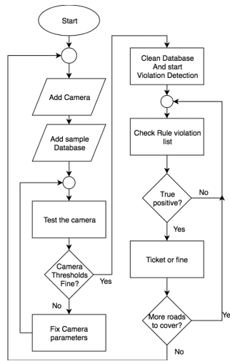

Figure 1: System Architecture

* **METHODOLOGY:**

# Image Processing:

* **Gray scaling and blurring**

Pre-processing the input video is essential for getting the best accuracy, and the video is blurred and grayscaled using the Gaussian blur approach.

Grey scaling has been applied to provide the best accuracy and reduce noise.

# Background Subtraction

Background subtraction has been used to subtract the current frame from the reference frame, yielding the necessary object's area.

The process is shown in Equation (1).

dist(I) = saturate(|frame1(I) − frame2(I)|)

# Binary Threshold

The binarization approach has been used to clean up the input video's noise and other imperfections.

Through this procedure, holes and noises are eliminated.

if frame(x, y) > threshold, dist(x, y) = MaxVal; otherwise

* **Dilation and find the contour**

When we obtain the threshold image, we must dilate to fill in the gaps. The contour is then calculated to reform the better image.

# Object Detection:

Regions with CNN features. Three-stage approach: -

1. By using support vendor machine (SVM), we can extract the objects from images.

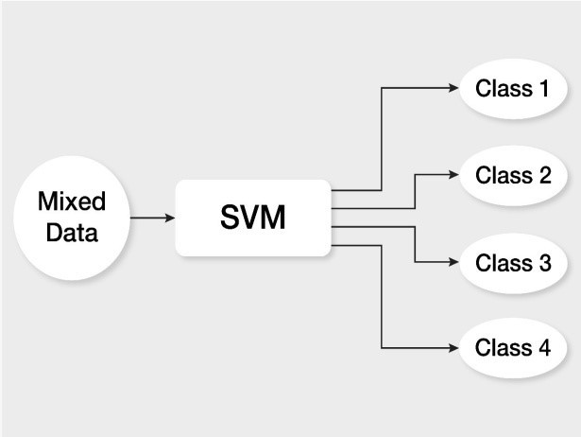

Figure 2: Algorithm used

1. By using convolutional neural network (CNN) we can extract the features from each region of image.
2. Classify and categorize each region using SVMs.

# Object Classification:

The moving items are extracted from the image after preprocessing. A vehicle categorization model divides the moving items into four categories: vehicles, non-vehicles, and things with four, two, and three wheels.

Based on a neural network model, this shows how the neural network architecture is designed.

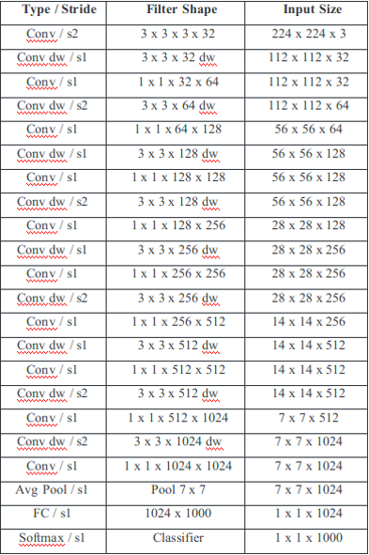

**CONVOLUTIONAL NEURAL NETWORK(CNN) :**

A deep learning method known as a convolutional neural network (CNN) is particularly effective at processing and recognising images. Convolutional layers, pooling layers, and completely connected layers are among the layers that make up this structure.

The key part of a CNN is its convolutional layers, where filters are used to extract characteristics like edges, textures, and forms from the input image. The output of the convolutional layers is then sent through pooling layers, which are employed to down-sample the feature maps and retain the most crucial data while lowering the spatial dimensions. One or more fully connected layers are then applied to the output of the pooling layers in order to predict or categorise the image.

CNNs are trained to recognise patterns and characteristics that are associated to certain objects or classes using a large collection of labelled images. A CNN may be trained to classify fresh images and can also be used to extract features for other tasks like object detection or image segmentation.

On a variety of image recognition tasks, such as object classification, object detection, and image segmentation, CNNs have demonstrated state-of-the-art performance. They have been utilised in a variety of applications, such as self-driving automobiles, medical imaging, and security systems. They are widely employed in computer vision, image processing, and related fields.

A convolutional neural network, or CNN, is a type of deep learning neural network created for evaluating structured arrays of data, such as photographs.

Design components like lines, gradients, circles, or even eyes and faces are very successfully recognised by CNN in the input image.

This property makes convolutional neural networks very powerful for computer vision.

CNN can be used directly on an underdone image without the need for any preparation.

Convolutional neural networks are feed-forward neural networks with up to 20 layers.

The convolutional layer, a specific kind of layer, is what gives convolutional neural networks their strength.

Each of the numerous convolutional layers that make up CNN is capable of recognising more complex shapes. These are put one on top of the other.

Handwritten digits can be recognised with three or four convolutional layers, while human faces can be distinguished with 25 layers.

The goal of this field is to enable machines to perceive the world similarly to humans do and to use that understanding for a variety of tasks, including image and Natural language processing, video recognition, picture analysis and classification, media reproduction, and other techniques.

**CONVOLUTIONAL NEURAL NETWORK DESIGN :**

The A convolutional neural network is built by stacking numerous invisible layers on top of one another in a specific order. It is a feed-forward neural network with many layers.

CNN is able to learn hierarchical properties thanks to the sequential design.

Convolutional layers are frequently used in CNN, followed by activation layers, grouping layers, and hidden layers.

The organisation of the Visual Cortex served as the inspiration for the pre-processing required in a ConvNet, which is similar to that of the analogous pattern of neurons in the human brain.

Different CNN Model Types:

▪ LeNet

▪ AlexNet

▪ ResNet

**SUPPORT VECTOR MACHINE:**

Support Vector Machine (SVM) is a supervised machine learning technique that may be used for both classification and regression. Although we also refer to regression issues, categorization is the most appropriate term. Finding a hyperplane in an N-dimensional space that clearly classifies the data points is the goal of the SVM method. The number of features determines the hyperplane's size. The hyperplane is essentially a line if there are just two input features. The hyperplane turns into a 2-D plane if there are three input features. Imagining something with more than three features gets challenging.

Take into account two independent variables, x1 and x2, as well as one dependent variable, either a blue or a red circle.

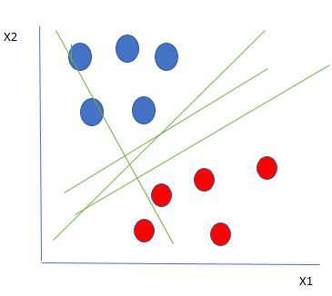

*Linearly Separable Data points*

It is extremely obvious from the above graphic that there are numerous lines that separate our data points or perform a classification between red and blue circles (our hyperplane in this case is a line as we are just taking into account two input features, x1, x2).

# Violation Detection:

Our project primarily focuses on a signal violation, which is one offence.

Signal violation: On the road, there are some predefined lines that we draw on the screen as needed. When vehicles cross these lines at an improper time or when the traffic signal is red, they are breaking the law.

Pictures of the automobiles are taken, and the number plate number is extracted.

* **RESULT**

The output of the signal violation detection system is: wherever the violation of traffic rule occurs, the system

takes a picture from the CCTV camera and then subtracts unnecessary image from it, providing the features of the vehicles in the image that are needed by the RCNN. This input video was gathered from CCTV footage when the signal violation detection system was executed on it. The input is preprocessed and after drawing predefined lines. The RCNN is used to detect whether the vehicle in the picture violates the traffic rule or not. Lastly, when

the car disobeys a traffic law. The system's cropped image of the moving violations almost exactly matches the one displayed. Later, using OpenCV, we can identify the vehicle's number plate number that disregarded the traffic law.

**INPUT**:

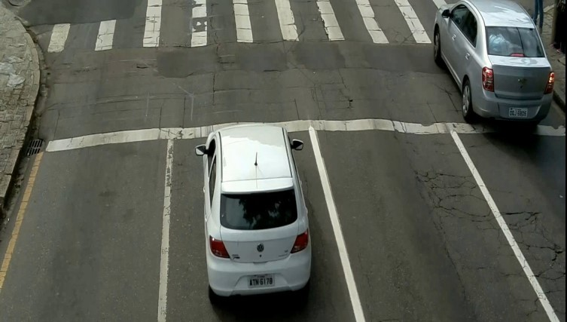

Figure 3: Initially captured picture

**OUTPUT**:

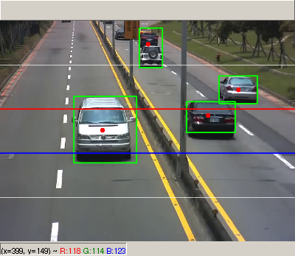

Figure 4 : Final output image which is cropped

**Signal Violation**:

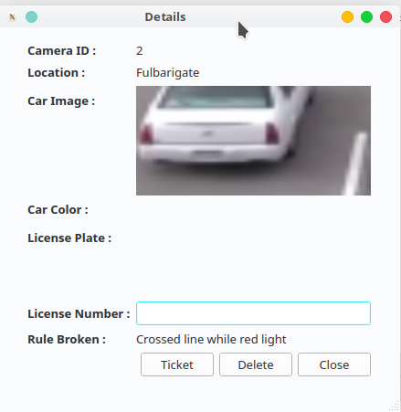

Figure 5 :Can extract speed and license number of vehicle.

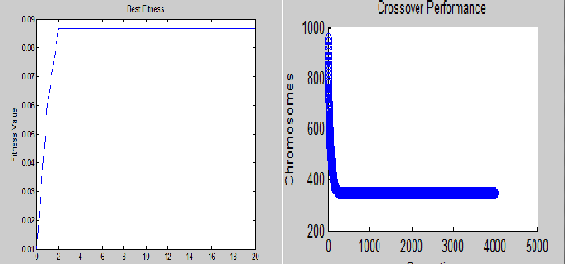

Figure 6: Best Fitness Plot and Crossover Performance

Shown in image 1 Initially whole image is captured from the CCTV camera. Executing the system given in Image 1 as input obtains an output cropped picture shown in Image 2. Finally the runtime of the whole executing process is 6.55 seconds.

* **CONCLUSION**

The developed algorithm that is now being used is capable of detecting the type of violation described in this project, which is disobeying traffic signals and signal violation. The project's objective is to reduce traffic police officers' workload by automatically identifying violations and making it simple for the traffic police department to manage and monitor traffic and take swift and efficient action against the violating vehicle owner in the event of a lack of traffic police to prevent accidents and lessen the workload for the traffic police. to raise awareness of the significance of everyone abiding by the rules of the road.

* **FUTURE WORK**

The suggested system recognises signal violations. Additionally, using a computer with a GPU or high-speed processor specifications can improve the programme runtime. Future analysis of the algorithm's software may make use of additional cutting-edge image processing methods. The addition of penalty points will allow us to determine which vehicle has the most challan in the future. We can increase the system's programme runtime by skipping the unnecessary backend steps. As opposed to adding extra intelligence, a computer vision algorithm was applied. Our long-term goal is to strengthen this system by including number plate detection with OCR and penalty points. The concept of "penalty points" will be used to implement all traffic rule violation detection. Whenever the number plate is detected, we will be able to locate penalty points on top of the vehicle. A vehicle's penalty points are the number of unpaid challans as of the time the point was tallied. This concept will make it simple for police officers to use cameras and take immediate action on vehicles with a high number of penalty points.

* **REFERENCES:**

[1] Dat Tran, To train your own Object Detector with TensorFlow‟s Object Detector API | 2021 | Towards Data Science.

1. [2] P.Srinivas Reddy, Ramesh O., "A Video-Based Traffic Violation Detection System," Sep 2019.

[3] Madhuravani S., Deepthi N. B., Umar S., Gouse "Passenger Compartment Violation Detection in HOV/HOT Lanes," in Aug 2019

[4]Sowmya G., Divya Jyothi G., Shirisha N., Navya K., Active learning strategies in engineering education, Journal of Advanced Research in Dynamical and Control Systems, Jan 2021.

[5] Mukremin Ozkul , Ilir Capuni(2018).” Police-less multiparty traffic violation detection and reporting system with privacy preservation”, IET Intelligent Transport Systems, Vol. 12 No. 5, pp. 351-358.

1. Rhen Anjerome Bedruz, Aaron Christian P. Uy, Ana Riza Quiros, Robert Kerwin Billones, Edwin Sybingco, Argel Bandala, Elmer P. Dadios (2019). “A Robotic Model Approach of an Automated Traffic Violation Detection System with Apprehension” 2018 IEEE 10th International Conference on Humanoid, Nanotechnology, Information Technology,Communication and Control, Environment and Management (HNICEM), pp. 1-4.
2. SamirA.Elsagheer Mohamed (2019).“Automatic Traffic Violation Recording and Reporting System to Limit Traffic Accidents: Based on Vehicular Ad-hoc Networks (VANET)”. 2019 International Conference on Innovative Trends in Computer Engineering (ITCE), pp. 254-259.
3. Siddharth Tripathi, Uthsav Shetty, Asif Hasnain, Rohini

Hallikar (2019), „Cloud Based Intelligent Traffic System